Machine Learning (ML)

What is Machine Learning?
Machine Learning is a branch of Artificial Intelligence (AI) that enables computers to learn patterns from data and make decisions or predictions without being explicitly programmed for specific tasks. Instead of following strict rules, ML models improve their performance by learning from experience (data).

Why Machine Learning?
- Automates decision-making in complex or large-scale problems.
- Helps uncover hidden patterns in data.
- Enables predictive analytics and intelligent applications (e.g., speech recognition, recommendation systems).

Types of Machine Learning
Machine Learning can be broadly classified into three main types based on the nature of the learning signal or feedback:

1. Supervised Machine Learning
Definition:
The model learns from a labeled dataset, where each input data point is paired with the correct output (label). The goal is to learn a mapping from inputs to outputs so the model can predict labels on new, unseen data.
Characteristics:
- Input-output pairs are known.
- Model is “supervised” with correct answers during training.
Examples:
• Classification: Predict discrete class labels.
- Example: Email spam detection (spam or not spam), handwritten digit recognition (digits 0–9).
• Regression: Predict continuous numeric values.
- Example: Predicting temperature, stock prices, or house prices.
Common Algorithms:
- Linear Regression
- Decision Trees
- Random Forest
- Neural Networks

2. Unsupervised Learning
Definition:
The model learns patterns from unlabeled data, where no output labels are provided. The goal is to find inherent structures or groupings in the data.
Characteristics:
- No labels; the model tries to infer patterns.
- Useful for exploratory analysis or feature learning.
Examples:
- Grouping customers into segments based on purchasing behavior (Clustering).
- Reducing the dimensionality of data while preserving important information (Dimensionality Reduction).
Common Algorithms:
- K-Means Clustering
- Hierarchical Clustering
- Principal Component Analysis (PCA)

3. Reinforcement Learning
Definition:
An agent learns to make decisions by interacting with an environment and receiving feedback in the form of rewards or penalties. The goal is to learn a policy that maximizes cumulative rewards over time.
Characteristics:
- Learning is based on trial and error.
- Feedback is delayed and sparse (rewards, not labels).
- Commonly used in sequential decision-making tasks.
Examples:
- Training a robot to walk.
- Teaching an AI to play chess or

Linear Algebra
Introduction:
Linear algebra is a branch of mathematics that deals with vectors, matrices, and linear transformations. It is a foundational tool in machine learning, particularly in data representation, model construction, optimization algorithms, and deep learning architectures. Machine learning algorithms often rely on operations involving vectors and matrices for computation and data manipulation.
Why Linear Algebra is Needed in Machine Learning:
- Data Representation:
Machine learning datasets are often represented in the form of matrices, where rows correspond to individual data samples and columns correspond to features.
- Model Parameters:
Model weights and biases are typically stored as vectors and matrices. For example, in linear regression, the weights are stored as a vector.
- Efficient Computation:
Many algorithms perform matrix operations like dot products and matrix multiplication, which are computationally efficient using linear algebra.
- Transformations and Dimensionality Reduction:
Techniques like Principal Component Analysis (PCA) rely on eigenvectors and eigenvalues from linear algebra to reduce the dimensions of datasets.
- Gradient Descent Optimization:
Gradient vectors are used to update parameters during optimization, especially in deep learning models.

Vectors:
A vector is a one-dimensional array of numbers (scalars). It can be visualized as a directed line segment in space with both magnitude and direction.
Example:
Let v be a column vector:
v =
[ 2
4
6 ]
This is a 3-dimensional vector.
Vector Addition:
Vectors of the same dimension can be added by adding corresponding elements.

Vector Scaling (Scalar Multiplication):
Scalar multiplication involves multiplying each component of a vector by a scalar (a single number).

Linear Combination
A linear combination is the sum of scalar multiples of vectors. It is a way of combining vectors using scalar weights.
Definition:
Given vectors v₁, v₂, ..., vₙ and scalars a₁, a₂, ..., aₙ, the expression:
a₁v₁ + a₂v₂ + ... + aₙvₙ
is called a linear combination of the vectors v₁ through vₙ.
Example:
Let
v₁ = [1, 2],
v₂ = [3, 4],
and scalars a₁ = 2, a₂ = -1.
Then,
a₁v₁ + a₂v₂ = 2*[1, 2] + (-1)*[3, 4]
= [2, 4] + [-3, -4]
= [-1, 0]
This result is a linear combination of v₁ and v₂.

Span
The span of a set of vectors is the set of all possible linear combinations of those vectors.
Definition:
The span of vectors v₁, v₂, ..., vₙ is:
Span(v₁, v₂, ..., vₙ) = { a₁v₁ + a₂v₂ + ... + aₙvₙ | a₁, a₂, ..., aₙ ∈ ℝ }
This is the set of all points you can reach using linear combinations of the given vectors.
Example:
Let
v₁ = [1, 0],
v₂ = [0, 1]
The span of {v₁, v₂} is ℝ², the entire 2D plane. Any point [x, y] can be written as:
x*[1, 0] + y*[0, 1] = [x, y]
So, v₁ and v₂ span ℝ².

Basis Vectors
A basis is a set of vectors that is both:
- Linearly independent, and
- Span the entire vector space
Definition:
A set of vectors {v₁, v₂, ..., vₙ} is a basis for a vector space V if:
- Every vector in V can be written as a unique linear combination of {v₁, ..., vₙ}
- None of the vectors in the set is a linear combination of the others
Standard Basis in ℝ² and ℝ³:
In ℝ²:
The standard basis is { [1, 0], [0, 1] }
In ℝ³:
The standard basis is { [1, 0, 0], [0, 1, 0], [0, 0, 1] }
Example:
Let v₁ = [1, 0], v₂ = [0, 1]
- They are linearly independent
- They span ℝ²
So, they form a basis for ℝ².

Linear Transformation
A linear transformation is a function between two vector spaces that preserves the operations of vector addition and scalar multiplication.
Definition:
A transformation T: ℝⁿ → ℝᵐ is linear if for all vectors u, v ∈ ℝⁿ and scalars c ∈ ℝ, the following hold:
- T(u + v) = T(u) + T(v)
- T(cu) = cT(u)
Linear transformations map straight lines to straight lines (or points) and preserve the origin.
Examples:
- Rotation
- Scaling
- Reflection
These operations can be represented using matrices.

2. Matrices as Linear Transformations
Any linear transformation can be represented as matrix multiplication.
If T(x) = A·x, where:
- x is a vector in ℝⁿ
- A is an m×n matrix
- Then T(x) is the image of x under the linear transformation defined by matrix A
This is a very powerful concept in machine learning and data science, as we can perform transformations on data by simply multiplying it with matrices.
Example:
Let
A =
[ [2, 0],
[0, 3] ]
and vector x = [1, 2]

Then:
T(x) = A·x
[ [2, 0],
[0, 3] ] · [1, 2]
= [ (2×1 + 0×2), (0×1 + 3×2) ]
= [2, 6]
This transformation stretches the x-component by 2 and the y-component by 3 (i.e., non-uniform scaling).

3. Geometric Interpretation
Matrix-based linear transformations alter the shape or orientation of vectors or entire spaces. The most common geometric transformations are:
- Scaling: Multiplies the length of vectors
- Rotation: Rotates vectors around the origin
- Reflection: Mirrors vectors across a line or plane
- Shearing: Slants the shape of an object
These transformations can be visualized using a matrix that maps the unit vectors of a space (e.g., [1, 0] and [0, 1] in 2D) to new positions.

4. Composition of Transformations
Multiple linear transformations can be composed using matrix multiplication.
If T₁(x) = A·x and T₂(x) = B·x, then
T₂(T₁(x)) = B·(A·x) = (B·A)·x
So, the composition of two transformations is another transformation whose matrix is the product of the two matrices.

5. Identity and Inverse Transformations
- The identity matrix I does nothing to a vector: I·x = x
- The inverse of a matrix A⁻¹ (if it exists) undoes the effect of A: A⁻¹·(A·x) = x
This concept is essential in solving linear systems and understanding reversibility of transformations.

6. Applications in Machine Learning
- Feature Scaling and Normalization: Viewed as linear transformations.
- Principal Component Analysis (PCA): Projects data into a new space using eigenvectors (linear transformations).
- Neural Networks: Use weight matrices to linearly transform inputs before applying nonlinear activation functions.
- Transformers in NLP: Use attention mechanisms that involve matrix multiplications.

Matrix Multiplication as Composition of Linear Transformations
Matrix multiplication can be understood as composition of linear transformations. When we apply multiple transformations to a vector, the final result can be obtained by multiplying the corresponding matrices and then applying the resulting matrix to the vector.
Linear Transformation Recap
A linear transformation is a function that maps a vector to another vector using a matrix:
If
T₁(x) = A·x
T₂(x) = B·x
Then applying T₁ followed by T₂ to a vector x gives:
T₂(T₁(x)) = B·(A·x)
This is equivalent to a single transformation:
T(x) = (B·A)·x
Thus, matrix multiplication corresponds to composing transformations.

3. Why Order Matters (Non-Commutativity)
Matrix multiplication is not commutative, i.e., A·B ≠ B·A in general.
This reflects the fact that the order in which transformations are applied matters.
Example:
Let
A = scaling matrix
B = rotation matrix
Applying scaling first and then rotation is not the same as applying rotation first and then scaling. So:
B·A ≠ A·B

4. Example with 2D Vectors
Let:
A =
[ [2, 0],
[0, 2] ] → scaling by 2
B =
[ [0, -1],
[1, 0] ] → 90° rotation counterclockwise
Let x = [1, 0]
First apply A:
A·x = [2, 0]
Then apply B:
B·(A·x) = B·[2, 0] = [0, 2]
Now compute the matrix product B·A:
B·A =
[ [0, -1],
[1, 0] ] · [ [2, 0],
[0, 2] ]
= [ [0×2 + (-1)×0, 0×0 + (-1)×2],
[1×2 + 0×0, 1×0 + 0×2] ]
= [ [0, -2],
[2, 0] ]
Now apply (B·A)·x = [0, -2] as expected.

5. Interpretation in Machine Learning
Matrix compositions are fundamental in:
- Neural networks: Layers apply successive linear transformations via weight matrices.
- Data preprocessing pipelines: Multiple transformations like scaling, rotating, or projecting features.
- PCA and SVD: Decompose and recompose data using linear transformations.

Three-Dimensional Linear Transformations
A three-dimensional linear transformation is a function that maps vectors from ℝ³ to ℝ³ using a 3×3 matrix. It transforms 3D vectors while preserving the properties of linearity:
- Addition: T(u + v) = T(u) + T(v)
- Scalar multiplication: T(cu) = c·T(u)
Such transformations include rotations, scalings, reflections, shears, and combinations of these in 3D space.

2. Matrix Representation
A linear transformation T in ℝ³ is represented by:
T(x) = A·x
Where:
- x is a 3×1 column vector [x, y, z]ᵗ
- A is a 3×3 matrix
- T(x) is the transformed 3D vector
General form of matrix A:
A =
[ [a₁₁, a₁₂, a₁₃],
[a₂₁, a₂₂, a₂₃],
[a₃₁, a₃₂, a₃₃] ]

3. Types of Transformations in ℝ³
a. Scaling
Uniform or non-uniform stretching/shrinking of axes.
Example:
A =
[ [2, 0, 0],
[0, 3, 0],
[0, 0, 1] ]
Scales x by 2, y by 3, and keeps z unchanged.
b. Rotation
Rotation about one of the coordinate axes.
- Rotation about z-axis (by angle θ):
A =
[ [cosθ, -sinθ, 0],
[sinθ, cosθ, 0],
[0, 0, 1] ]
Similar matrices exist for rotation about x or y axes.
c. Reflection
Flips points over a plane.
Example:
Reflection over the xy-plane:
A =
[ [1, 0, 0],
[0, 1, 0],
[0, 0, -1] ]
d. Shearing
Alters angles between axes without changing volume uniformly.
Example:
Shear in x-direction proportional to z:
A =
[ [1, 0, k],
[0, 1, 0],
[0, 0, 1] ]

4. Geometric Interpretation
In 3D space:
- Vectors are points or arrows from the origin.
- Transformations change their position, length, or direction.
- Linear transformations always map the origin to the origin.
- The coordinate grid gets stretched, rotated, or skewed depending on the matrix.

5. Composition of Transformations
Successive 3D transformations can be applied by multiplying the transformation matrices:
If T₁(x) = A·x and T₂(x) = B·x,
Then: T₂(T₁(x)) = B·A·x
Note: Matrix multiplication is not commutative: B·A ≠ A·B

6. Applications in Machine Learning and Graphics
- Computer Graphics: Rendering 3D scenes using transformations.
- 3D Data Augmentation: Rotating and scaling 3D point cloud data.
- Robotics: Modeling motion of objects in 3D space.
- PCA/Dimensionality Reduction: Applying transformations to data in 3D space.

Determinant
The determinant is a scalar value that can be computed from a square matrix. It provides important information about the matrix and the linear transformation it represents.
For a matrix A, the determinant is written as det(A) or |A|.

2. Geometric Meaning
- In 2D, the determinant represents the area scaling factor of the transformation.
- In 3D, it represents the volume scaling factor.
- A determinant of 0 means the matrix collapses space, i.e., the transformation maps all space into a lower dimension — such matrices are not invertible.

3. Determinant of a 2×2 Matrix
For a matrix:
A =
[ [a, b],
[c, d] ]
The determinant is:
det(A) = ad - bc
Example:
A =
[ [3, 2],
[1, 4] ]
det(A) = (3)(4) - (2)(1) = 12 - 2 = 10

4. Determinant of a 3×3 Matrix
For a matrix:
A =
[ [a, b, c],
[d, e, f],
[g, h, i] ]
The determinant is:
det(A) = a(ei − fh) − b(di − fg) + c(dh − eg)
Example:
A =
[ [1, 2, 3],
[4, 5, 6],
[7, 8, 9] ]
det(A) = 1(5×9 − 6×8) − 2(4×9 − 6×7) + 3(4×8 − 5×7)
= 1(45 − 48) − 2(36 − 42) + 3(32 − 35)
= 1(−3) − 2(−6) + 3(−3)
= −3 + 12 − 9 = 0
So this matrix is not invertible.

5. Properties of Determinants
- det(AB) = det(A)·det(B)
- det(Aᵀ) = det(A) (transpose doesn't change determinant)
- det(I) = 1, where I is the identity matrix
- If rows/columns are swapped, determinant sign changes
- If two rows/columns are identical, determinant = 0
- If det(A) = 0, then A is singular (not invertible)
Applications in Machine Learning and Data Science
- Invertibility Check: A matrix with det ≠ 0 is invertible. Inverting matrices is common in solving systems of linear equations and in model optimization.
- Volume/Area Interpretation: In PCA, the determinant of the covariance matrix helps understand variance spread.

Inverse matrices, column space and null space
1. Inverse Matrices
- The inverse of a square matrix A, denoted as A⁻¹, is a matrix such that:
A · A⁻¹ = I, where I is the identity matrix.
- Conditions:
  - Only square matrices can have an inverse.
  - A⁻¹ exists only if det(A) ≠ 0 (i.e., A is non-singular).
- Use:
  - Solving linear systems: If Ax = b, then x = A⁻¹b.

2. Column Space
- The column space (also called range) of a matrix A is the set of all linear combinations of its column vectors.
- It represents all the vectors that A can map to.
- For an m×n matrix, the column space is a subspace of ℝᵐ.
- Dimension of column space = rank of the matrix.
- Important for:
  - Understanding what outputs are possible from Ax.
  - Determining if a system of equations Ax = b has a solution (i.e., b must lie in the column space).

3. Null Space
- The null space of a matrix A consists of all vectors x such that Ax = 0.
- It represents the kernel or solution space of the homogeneous system.
- For an m×n matrix, the null space is a subspace of ℝⁿ.
- If null space contains only the zero vector, A has full column rank.
- Important for:
  - Finding dependencies among columns.
  - Understanding solution behavior of Ax = b (especially when multiple solutions exist).

Nonsquare matrices as transformations between dimensions
A nonsquare matrix has a different number of rows and columns (e.g., 3×2, 2×4, etc.).
While square matrices transform vectors within the same dimension (e.g., ℝ² → ℝ²), nonsquare matrices represent transformations between different dimensions.

2. Transformation Meaning
Let A be an m×n matrix:
- Input vector x ∈ ℝⁿ
- Output vector Ax ∈ ℝᵐ
So, A defines a transformation:
T: ℝⁿ → ℝᵐ
This means:
- If n > m → projection from higher to lower dimension (dimensionality reduction)
- If n < m → mapping from lower to higher dimension (embedding)

3. Examples
a. 2×3 Matrix (ℝ³ → ℝ²):
A =
[ [1, 0, -1],
[2, 1, 0] ]
x = [x₁, x₂, x₃]ᵗ ∈ ℝ³
Ax ∈ ℝ² → compresses 3D input into 2D output (e.g., projection)
b. 3×2 Matrix (ℝ² → ℝ³):
A =
[ [1, 0],
[0, 1],
[1, 1] ]
x = [x₁, x₂]ᵗ ∈ ℝ²
Ax ∈ ℝ³ → maps 2D input into 3D output (e.g., embedding a plane in 3D)

4. Geometric Interpretation
- n > m (more columns):
  - Reduces dimensions
  - Loses information (compression)
  - Common in PCA, projections, dimensionality reduction
- n < m (more rows):
  - Expands dimensions
  - Cannot cover all of ℝᵐ (output is restricted to a subspace)
  - Used in feature embedding, upscaling

5. Applications in Machine Learning
- PCA: Reduces high-dimensional data using a transformation matrix (n×k with k < n).
- Neural networks: Each layer uses weight matrices to map between spaces of different dimensions.
- Word embeddings: Map words (ℝ¹-hot vectors) into lower/higher dimensional semantic spaces.

Dot products and duality
Dot Product (Inner Product)
The dot product is a fundamental operation in linear algebra that takes two vectors and returns a scalar.
Definition:
For two vectors a and b in ℝⁿ,
a · b = a₁b₁ + a₂b₂ + ... + aₙbₙ
Or, using matrix notation:
a · b = aᵀb

2. Geometric Interpretation
- The dot product measures how much one vector extends in the direction of another.
- It can also be written as:
a · b = ||a|| · ||b|| · cos(θ)
where θ is the angle between the vectors.
- If θ = 0° (same direction): a · b = ||a|| · ||b|| (maximum)
- If θ = 90° (perpendicular): a · b = 0
- If θ = 180° (opposite direction): a · b = -||a|| · ||b||

3. Properties of the Dot Product
- Commutative: a · b = b · a
- Distributive: a · (b + c) = a · b + a · c
- Bilinear: Linear in both operands
- Scalar multiplication: (k·a) · b = k(a · b)

4. Use of Dot Product in Machine Learning
- Cosine similarity: Measures similarity between vectors (e.g., documents, embeddings)
- Projections: Projecting one vector onto another uses dot product
- Linear regression: Predictions are computed using dot products (wᵀx)
- Neural networks: Weighted sums of inputs involve dot products at each layer

5. Duality
Duality in linear algebra refers to the relationship between vectors and linear functions (covectors).
- Every vector v in ℝⁿ can be associated with a linear functional (a function from vectors to scalars).
- This linear functional maps another vector x to the scalar v · x.
- In this sense, v acts like a row vector (covector), and x is a column vector.
Key Idea:
- A column vector defines a direction or point in space.
- The same vector as a row defines a linear function (dual view).
- This is useful in differentiation, optimization, and advanced geometry.

Cross products
The cross product is a binary operation on two vectors in three-dimensional space (ℝ³) that produces another vector perpendicular to both input vectors.
It is defined only in 3D space and is used to compute orthogonal vectors, areas, and torques in physics and engineering.

2. Definition
Given two vectors:
a = [a₁, a₂, a₃]
b = [b₁, b₂, b₃]
The cross product of a × b is defined as:
a × b = [a₂b₃ - a₃b₂, a₃b₁ - a₁b₃, a₁b₂ - a₂b₁]
Or in determinant form:
a × b =
|i j k|
|a₁ a₂ a₃|
|b₁ b₂ b₃|

3. Properties of the Cross Product
- Anti-commutative: a × b = –(b × a)
- Distributive over addition: a × (b + c) = a × b + a × c
- Not associative: (a × b) × c ≠ a × (b × c)
- Perpendicular vector: Resulting vector is orthogonal to both a and b
- Zero vector: a × b = 0 if a and b are parallel or one is a zero vector

4. Geometric Interpretation
- The magnitude of a × b is equal to the area of the parallelogram formed by a and b:
||a × b|| = ||a|| · ||b|| · sin(θ)
where θ is the angle between a and b.
- The direction of the result follows the right-hand rule:
  - Point index finger along a, middle finger along b, then the thumb points in the direction of a × b.

Cross Products in the Light of Linear Transformations
The cross product can be interpreted within the framework of linear transformations in three-dimensional space. It can be viewed as a special kind of linear map that takes one vector and returns another vector orthogonal to it, depending on a fixed vector.
Cross Product as a Linear Transformation
For a fixed vector a in ℝ³, the operation:
Tₐ(b) = a × b
defines a linear transformation Tₐ: ℝ³ → ℝ³ that maps any vector b to the vector a × b.
This transformation is linear because it satisfies:
- Additivity: Tₐ(b + c) = a × (b + c) = a × b + a × c = Tₐ(b) + Tₐ(c)
- Homogeneity: Tₐ(kb) = a × (kb) = k(a × b) = k Tₐ(b)

Cramer's Rule
Cramer's Rule is a method to solve a system of n linear equations with n variables using determinants.
Given the system:
A * x = b,
where A is an n×n invertible matrix, x is the vector of variables, and b is the constants vector.
To find the value of each variable xi:
- Compute det(A), the determinant of matrix A.
- Replace the i-th column of A with vector b to form a new matrix Ai
- Compute det(Ai​).
- The solution is:
- 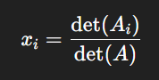
This works only if det(A) ≠ 0 (i.e., A is invertible).

Change of Basis with Example
Change of basis is the process of expressing a vector’s coordinates relative to one basis in terms of another basis.
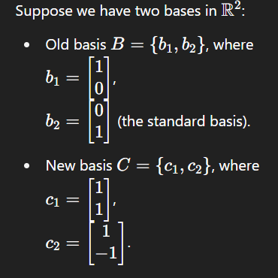
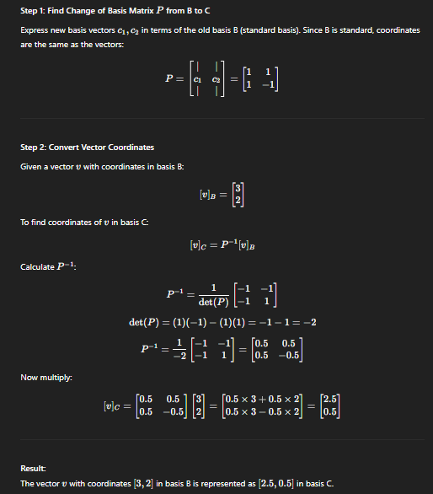

Eigenvectors and Eigenvalues
Definition:
Given a square matrix A of size n × n, an eigenvector v (a non-zero vector) and its corresponding eigenvalue λ satisfy the equation:
A v = λ v
This means that when the matrix A multiplies the vector v, the result is the same vector scaled by the scalar λ.
Key Points:
- v is an eigenvector if multiplication by A changes only its magnitude, not its direction.
- λ is the eigenvalue corresponding to eigenvector v.
- Eigenvectors are always non-zero.
- Eigenvalues can be real or complex numbers.
Finding Eigenvalues:
To find eigenvalues, solve the characteristic equation:
det(A - λ I) = 0
where I is the identity matrix of the same size as A.
Finding Eigenvectors:
For each eigenvalue λ, solve:
(A - λ I) v = 0
to find the corresponding eigenvector(s).
Example:
Let
A = [ [4, 1],
[2, 3] ]
- Find eigenvalues by solving:
det( [ [4 - λ, 1],
[2, 3 - λ] ] ) = 0
Calculating the determinant:
(4 - λ)(3 - λ) - 2 × 1 = 0
Expanding:
(4 - λ)(3 - λ) - 2 = 0
12 - 4λ - 3λ + λ² - 2 = 0
λ² - 7λ + 10 = 0
Factoring:
(λ - 5)(λ - 2) = 0
So eigenvalues are λ₁ = 5 and λ₂ = 2.
- For λ₁ = 5, solve:
(A - 5I) v = 0 ⇒
[ [-1, 1],
[ 2, -2] ] v = 0
From the first row:
-1 × v₁ + 1 × v₂ = 0 ⇒ v₂ = v₁
Eigenvector corresponding to λ = 5 is any non-zero scalar multiple of [1, 1].
Applications:
- Principal Component Analysis (PCA) to find directions of maximum variance.
- Solving differential equations.
- Stability and vibration analysis.
- Quantum mechanics and more.
Eigenvectors and eigenvalues are fundamental concepts in many machine learning algorithms and data analysis techniques.

Probability Density Function (PDF)
Definition:
A Probability Density Function (PDF) is a statistical expression that defines the likelihood (or density) of a continuous random variable falling within a particular range of values.
It is a mathematical function that describes the probability distribution of a continuous random variable.
The main difference between the probability mass function (PMF) and the probability density function (PDF) is that the PMF is used to describe the probabilities of discrete random variables, while the PDF is used to describe the probabilities of continuous random variables.
The probability density function (PDF) gives the density of the probability distribution over a range of values for a continuous random variable. The area under the PDF over a certain range of values gives the probability of the random variable falling within that range.
The area under a probability density function (PDF) graph represents the probability of the random variable falling within a certain range of values.
Key Characteristics of PDF:
- Used for continuous random variables:
  - Applicable when the variable can take any real value within a range.
  - Example: Height, weight, temperature, etc.
- Probability is measured over an interval:
  - The probability that a continuous variable takes on a specific value is always zero.
  - Instead, we calculate the probability that the variable falls within an interval [a, b].
- Total area under the curve equals 1:
  - The integral (area) under the entire PDF curve over all possible values of the variable equals 1.
- PDF is non-negative:
  - For all x, f(x) ≥ 0
Mathematical Formulation:
If X is a continuous random variable with probability density function f(x), then:
- Probability between two values a and b:
P(a ≤ X ≤ b) = ∫[a to b] f(x) dx
- Total probability:
∫[−∞ to ∞] f(x) dx = 1
Example:
Suppose X is a continuous random variable representing height in cm, and it follows a normal distribution with a given mean and standard deviation. The PDF of the normal distribution is:
f(x) = (1 / (σ√(2π))) * e^(-(x - μ)² / (2σ²))
Here,
- μ is the mean
- σ is the standard deviation
- e is the base of the natural logarithm (≈ 2.718)
Visualization:
- The graph of a PDF is a smooth curve.
- The area under the curve between two points represents the probability that the variable falls in that range.
- For a normal distribution, the PDF is bell-shaped and symmetric around the mean.
Difference Between PDF and PMF:
Feature | PDF | PMF
Variable Type | Continuous random variable | Discrete random variable
Probability of value | 0 (calculated over interval) | Non-zero (at specific values)
Area/Value | Area under curve | Sum of individual probabilities
Cumulative Distribution Function (CDF) from PDF:
CDF is the cumulative probability up to a value x and is obtained by integrating the PDF from -∞ to x:
F(x) = ∫[−∞ to x] f(t) dt
Applications of PDF:
- Used in statistical modeling and hypothesis testing
- Helps in calculating probabilities for continuous variables
- Fundamental in defining and working with distributions like normal, exponential, and beta distributions
- Important in machine learning for estimating probability densities (e.g., KDE, Gaussian Naive Bayes).

Examples of PDF
a. The normal distribution PDF, which is a bell-shaped curve that is symmetric about the mean and has a fixed variance. It is commonly used to model natural phenomena such as heights, weights, and test scores.

b. The log-normal distribution PDF, which is a skewed distribution that is commonly used to model phenomena such as income and wealth, as well as some natural phenomena such as the sizes of earthquakes and meteorites.

c. The Poisson distribution PDF, which is a discrete distribution that is used to model the probability of a certain number of events occurring in a fixed interval of time or space. It is commonly used in fields such as biology, economics, and physics.

Normal Distribution

What is a Normal Distribution?
The Normal Distribution, also called the Gaussian Distribution, is a continuous probability distribution characterized by a bell-shaped curve that is symmetric about the mean.

Bell Curve:
- Mean = Median = Mode
- The curve is symmetric: left and right sides are mirror images.

Mathematical Formula:
The Probability Density Function (PDF) of the normal distribution is:
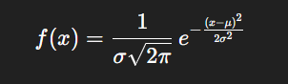
Where:
- μ = mean (center of the curve)
- σ= standard deviation (spread or width of the curve)
- e = Euler’s number ≈ 2.718

Why is Normal Distribution Needed?
- Many natural phenomena tends to follow it (Heights, weights, blood pressure, IQ scores.)
- Statistical inference assumes it: (Many parametric tests (like t-tests, ANOVA) assume normality.)
- Central Limit Theorem (CLT): The sum (or average) of many independent random variables tends to be normally distributed, regardless of the original distribution.

Properties of Normal Distribution

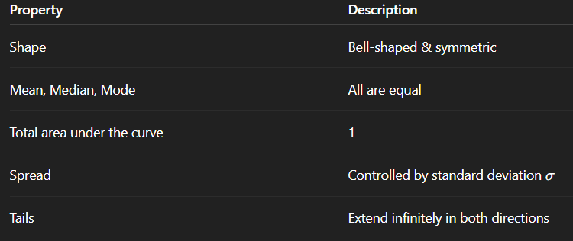

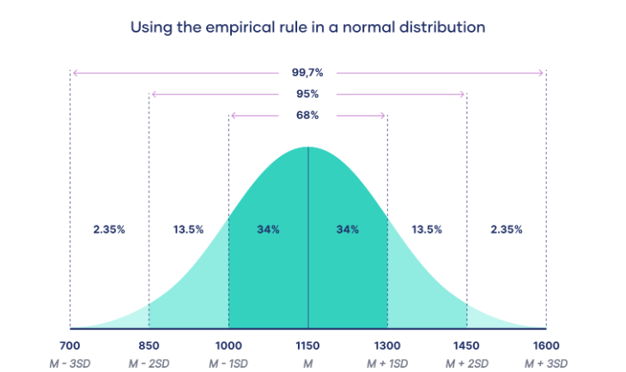
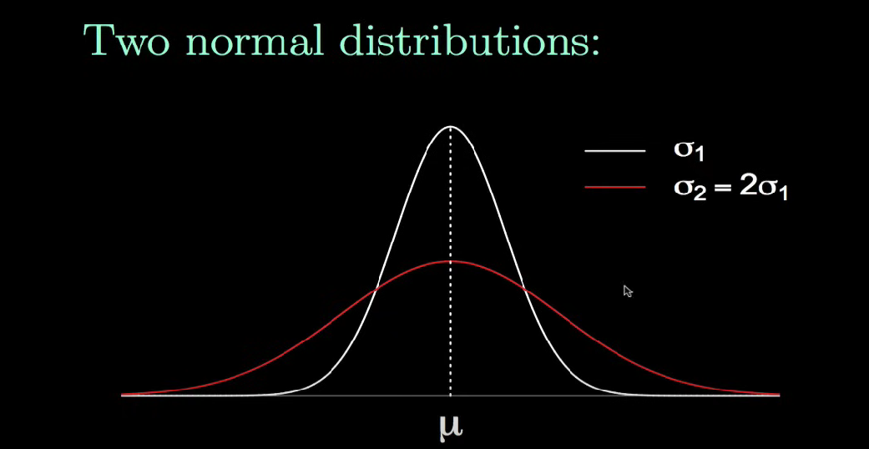

Standard Normal Distribution
• When μ=0 and σ=1, it’s called the Standard Normal Distribution.
• We can convert any normal distribution to standard normal using:
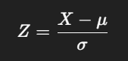

What is a Z-Score?
A Z-score (also called a standard score) tells you how many standard deviations a data point is from the mean of a distribution.

Why is Z-score useful?
- Compare values across different distributions
- Find probabilities using the standard normal distribution table
- Detect outliers (e.g., Z > 3 or Z < -3)

Finding the probability of a standard normal variable between certain values
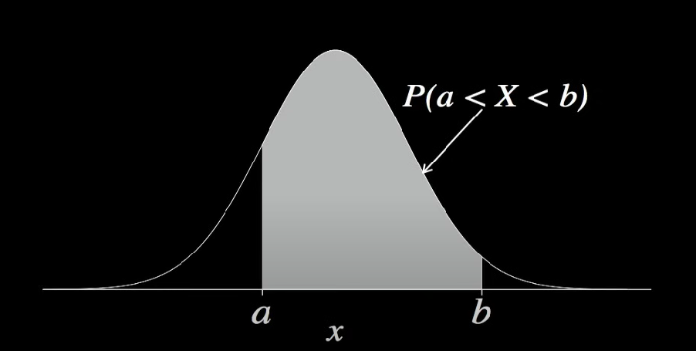

Central Limit Theorem – Detailed Notes
Definition:
The Central Limit Theorem (CLT) is a fundamental statistical concept that states: Given a sufficiently large sample size from a population with any shape distribution (with finite mean and variance), the sampling distribution of the sample mean will approximate a normal distribution. This approximation improves as the sample size increases.
Key Concepts:
- Population Distribution:
  - The original population can be of any shape: skewed, uniform, exponential, or even unknown.
  - However, the population must have a finite mean (μ) and finite variance (σ²).
- Sample:
  - A sample is a subset drawn from the population.
  - The sample mean is calculated for each sample.
- Sampling Distribution:
  - This is the distribution of the sample means calculated from many different samples of the same size from the population.
- Central Limit Theorem Statement:
  - As the sample size (n) increases, the distribution of the sample mean (X̄) approaches a normal distribution with:
    - Mean = μ (same as the population mean)
    - Standard deviation = σ/√n (called the standard error)
Mathematical Representation:
Let X₁, X₂, ..., Xₙ be a random sample of size n drawn from a population with mean μ and standard deviation σ. Let X̄ be the sample mean:
X̄ = (X₁ + X₂ + ... + Xₙ) / n
Then, as n → ∞:
Distribution of X̄ → N(μ, σ²/n)
This means the sample mean becomes approximately normally distributed with mean μ and variance σ²/n.
Conditions for CLT to Hold:
- The sample observations must be independent.
- The sample size should be sufficiently large. In most practical applications, a sample size of n ≥ 30 is considered sufficient.
- If the population is already normal, then even small samples (n < 30) will yield normally distributed sample means.
- If the population is not normal, then larger sample sizes are required for the CLT to apply accurately.

Importance of CLT:
- It allows us to use the normal distribution to make inferences about population parameters even when the population itself is not normally distributed.
- It is the theoretical basis for many statistical procedures including confidence intervals, hypothesis testing, and control charts.
- It enables approximation of probabilities related to sample means using the Z-distribution or t-distribution when the standard deviation is estimated.
Applications of CLT:
- Estimating population mean and standard deviation using sample data.
- Constructing confidence intervals for population parameters.
- Conducting hypothesis tests.
- Understanding the behavior of averages in large datasets.
- Used in quality control and process monitoring.
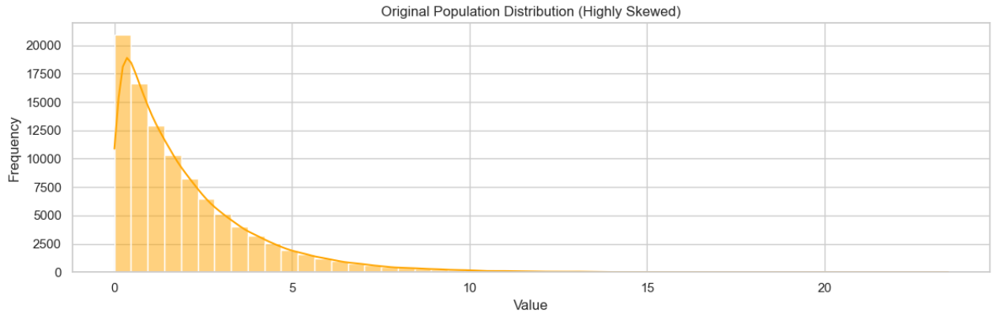
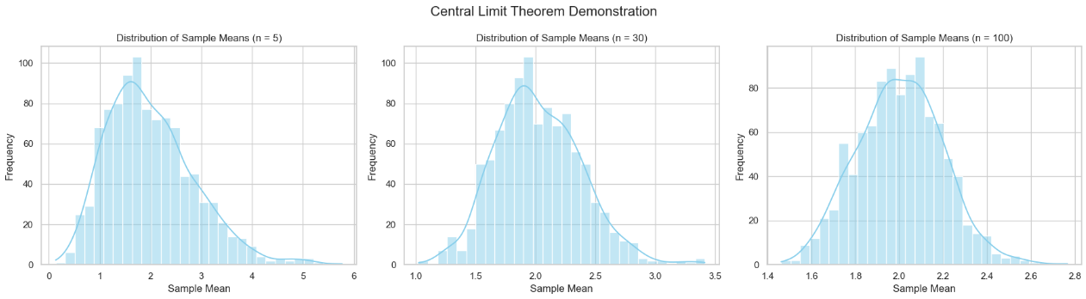

Example:
Suppose a population has a mean μ = 50 and standard deviation σ = 10. We take random samples of size n = 36.
By CLT:
- Mean of sample means = 50
- Standard deviation of sample means = 10 / √36 = 1.67
Even if the original population is not normal, the distribution of sample means will be approximately normal for large n.
Visual Understanding:
- Consider a population with a skewed distribution.
- Draw repeated random samples of size n from this population.
- Plot the means of these samples.
- As n increases, the histogram of sample means will resemble a normal distribution.
Relation to Standard Error:
The standard deviation of the sampling distribution (σ/√n) is called the standard error (SE). It measures how much the sample mean is expected to vary from the true population mean. Larger sample sizes result in smaller standard errors.
Limitations and Considerations:
- The theorem applies only to the distribution of sample means, not to individual data points.
- For small sample sizes, if the population is heavily skewed or has extreme outliers, CLT may not provide an accurate approximation.
- The quality of approximation improves with larger sample sizes.

